**MAJOR PROJECT**

HOME AUTOMATION USING MIT APP INVENTOR

Home Automation using MIT App Inventor is a project that aims to control various electronic devices and appliances in a home environment using a mobile application. MIT App Inventor is a visual programming platform that allows users to create mobile apps for Android devices without requiring extensive coding knowledge. It provides a drag-and-drop interface for designing the app's user interface and a block-based programming environment to define the app's behavior.

The project typically involves the following components and functionalities:

1. Mobile Application Design: The first step is to design the user interface of the mobile application using MIT App Inventor. This includes creating screens, buttons, labels, and other visual elements to interact with the home automation system.

2. Device Connectivity: The mobile application needs to establish communication with the electronic devices and appliances in the home. This can be achieved through various communication protocols such as Wi-Fi, Bluetooth, or Internet of Things (IoT) platforms like MQTT.

3. Device Control: Once the communication is established, the mobile app allows users to control the connected devices. For example, users can turn lights on or off, adjust the temperature of the thermostat, or control the operation of electronic appliances like fans or coffee machines.

4. Sensor Integration: Home automation often involves the use of sensors to monitor the environment and trigger certain actions. The project can include integrating sensors like motion detectors, temperature sensors, or humidity sensors into the system. The mobile app can display sensor readings and allow users to set up automation rules based on sensor values.

5. Automation and Scheduling: MIT App Inventor enables the creation of automation rules and scheduling features. Users can define conditions and actions to automate tasks based on specific events or time-based triggers. For example, turning off the lights automatically when no motion is detected for a certain period or scheduling the thermostat to adjust the temperature at specific times.

6. User Notifications: The mobile application can send notifications to users based on specific events or triggers. For instance, sending a notification when a motion is detected, or when a certain temperature threshold is reached.

7. Security and Access Control: Home automation systems often incorporate security features. The project can include implementing authentication mechanisms to ensure that only authorized users can control the devices. This can involve username/password authentication or integrating other security protocols like OAuth.

8. Data Logging and Analytics: The system can record and log various data points such as device states, sensor readings, and user interactions. This data can be analyzed to gain insights, monitor energy consumption, or optimize the automation rules.

9. Remote Access: MIT App Inventor allows for the creation of mobile apps that can provide remote access to the home automation system. This enables users to control and monitor their home devices even when they are away from home.

Overall, the project of Home Automation using MIT App Inventor combines the power of mobile application development and the ease of visual programming to create a user-friendly interface for controlling and managing electronic devices and appliances in a home environment.

SOME PROJECT RELATED PHOTOS

CIRCUIT DIAGRAM

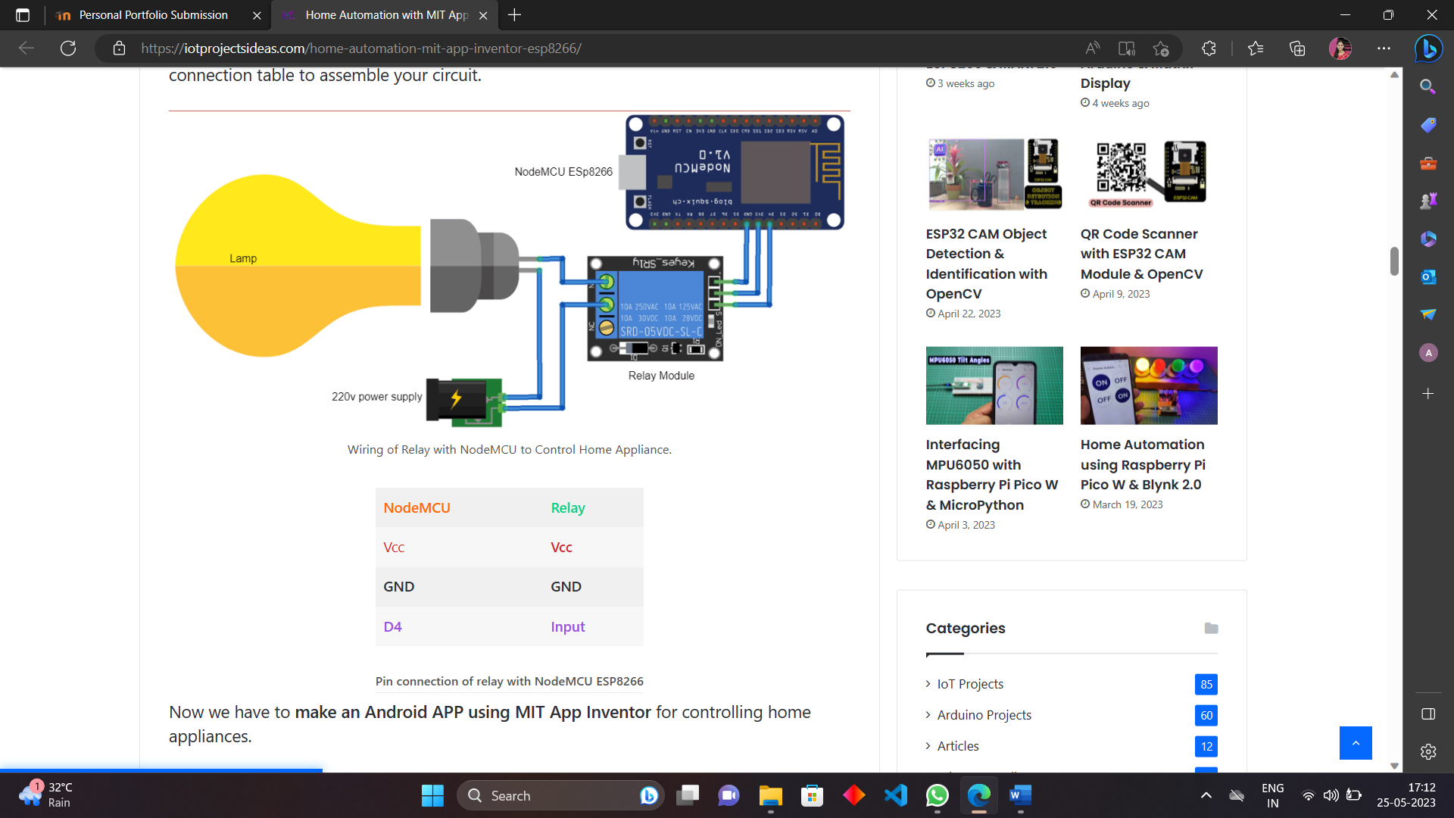

WORKING

